COP

ASSIGNMENT 1

Name: Sanket S Kapse

Q1. Wap to demonstrate ternary operator. define a variable marks ask its value from user and using ternary operator check if marks > 40 store "Pass" in result variable else store "Fail"

package Assignment1;

import java.util.*;

public class Q1 {

public static void main(String[] args)

{

Scanner s = new Scanner(System.***in***);

System.***out***.println("Enter Marks");

int marks= s.nextInt();

String result = (marks>40) ? "pass" : "fail";

System.***out***.println(result);

}

}

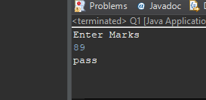

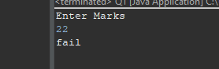

Q 2 using ternary check if number entered by user is positive or negative.  
In case number is positive store "Positive number" else store negative number to Result variable

package Assignment1;

import java.util.*;

public class Q2 {

public static void main(String[] args)

{

Scanner s= new Scanner (System.***in***);

System.***out***.println("enter number");

int number= s.nextInt();

String result = (number>0) ? "number is positive" : "number is negative" ;

System.***out***.println(result);

}

}

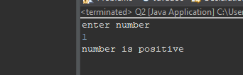

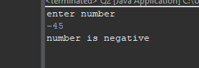

Q3. Q 3 WAP to ask name, age and salary of an employee and print on console.

package Assignment1;

import java.util.*;

public class Q3 {

public static void main(String[] args)

{

Scanner s= new Scanner(System.***in***);

int age;

String name;

float salary;

System.***out***.println("enter age");

age= s.nextInt();

System.***out***.println("enter name");

name= s.next();

System.***out***.println("enter salary");

salary= s.nextFloat();

System.***out***.println("age="+ age);

System.***out***.println("name="+ name);

System.***out***.println("salary="+ salary);

}

}

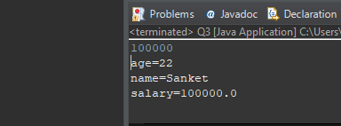

Q4. wap that ask two numbers from user and print greater number among two.

package Assignment1;

//Q4. wap that ask two numbers from user and print greater number among two.

import java.util.*;

public class Q4 {

public static void main(String[] args)

{

Scanner s= new Scanner (System.***in***);

int num1;

int num2;

int largest;

System.***out***.println("num 1");

num1 = s.nextInt();

System.***out***.println("num 2");

num2 = s.nextInt();

if(num1>num2)

largest = num1;

else

largest = num2;

System.***out***.println("Largest" + largest);

}

}

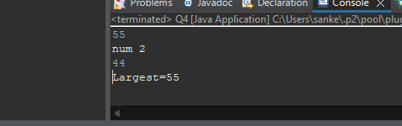

Q5. wap to ask product name and price of product from user and calculate discount i.e if price > 2000 then discount is 10 percent of price else discount is 7 % of price.

package Assignment1;

// Q5. wap to ask product name and price of product from user and calculate discount i.e

//if price > 2000 then discount is 10 percent of price else discount is 7 % of price.

import java.util.*;

public class Q5 {

public static void main(String[] args)

{

Scanner s= new Scanner(System.***in***);

String product;

float price;

System.***out***.println("Enter product");

product = s.next();

System.***out***.println("enter amount");

price= s.nextFloat();

if(price>2000)

System.***out***.println("discount is 10% :"+ price/100*10);

else

System.***out***.println("discount is 7% :"+ price/100*7);

}

}

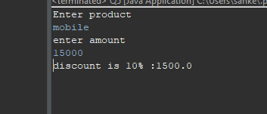

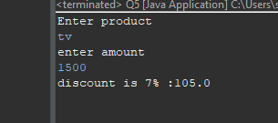

Q6. Wap to swap two numbers.

package Assignment1;

//Q6. Wap to swap two numbers.

import java.util.*;

public class Q6 {

public static void main(String[] args) {

Scanner s= new Scanner(System.***in***);

int num1=10;

int num2=20;

int temp;

System.***out***.println("before swapping : num1 = "+num1+ " num2 = " + num2);

temp=num1;

num1=num2;

num2=temp;

System.***out***.println("after swapping : num1 = "+ num1+ " num2 = " + num2);

}

}

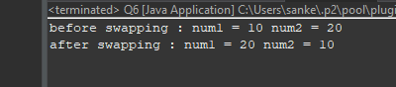

Q7. How to swap two numbers without using a third variable?

package Assignment1;

//Q7. How to swap two numbers without using a third variable?

import java.util.*;

public class Q7 {

public static void main(String[] args) {

int x=11;

int y=12;

System.***out***.println("before swapping x = "+ x + " y = " + y);

x= x + y;

y= x - y;

x= x - y;

System.***out***.println("after swapping x = "+ x +" y =" + y);

}

}

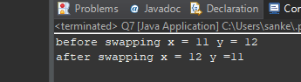

Q8. wap to check is number is even or odd.

package Assignment1;

//Q8. wap to check is number is even or odd.

import java.util.*;

public class Q8 {

public static void main(String[] args) {

Scanner s= new Scanner (System.***in***);

System.***out***.println("enter no=");

int no=s.nextInt();

if(no%2==0)

System.***out***.println("no is even");

else

System.***out***.println("no is odd");

}

}

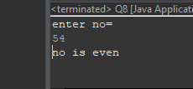

Q9. A school has following rules for grading system:  
 a. Below 25 - F  
 b. 25 to 45 - E  
 c. 45 to 50 - D  
 d. 50 to 60 - C  
 e. 60 to 80 - B  
 f. Above 80 - A  
 Ask user to enter marks and print the corresponding grade.

package Assignment1;

//Q9. A school has following rules for grading system:

//a. Below 25 - F

//b. 25 to 45 - E

//c. 45 to 50 - D

//d. 50 to 60 - C

//e. 60 to 80 - B

//f. Above 80 - A

//Ask user to enter marks and print the corresponding grade.

import java.util.*;

public class Q9 {

public static void main(String[] args) {

Scanner s=new Scanner (System.***in***);

int per;

System.***out***.println("Enter Per= ");

per= s.nextInt();

if(per<25)

System.***out***.println("Grade F");

else if(per>25 && per<45)

System.***out***.println("Grade E");

else if(per>45 && per<50)

System.***out***.println("Grade D");

else if(per>50 && per<60)

System.***out***.println("Grade C");

else if(per>60 && per<80)

System.***out***.println("Grade B");

else if(per>80)

System.***out***.println("Grade A");

else

System.***out***.println("Ivalid");

}

}

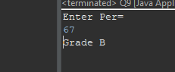

Q10.wap to check greater number among three numbers

package Assignment1;

//Q10.wap to check greater number among three numbers

public class Q10 {

public static void main(String[] args) {

int a=11;

int b=22;

int c=33;

int maximum =( a>b ? ( a>c ? a:c ): ( b>c ? b:c ) );

System.***out***.println(maximum);

}

}

